Task 12 – Evidence Report
Reproducibility and Version Pinning for the DSYS601 Observability Lab
Student | Kabir Singh Thukrai
Student ID | 99281336
Course | BCIS309 – Work Integrated Learning Project
Task | Task 12 – Reproducibility / version-pinning strategy (manifests version-controlled in GitHub)
Release tag | v1.0-lab-baseline
Repository | https://github.com/kat0870/dsys601-k8s-observability-lab
Date | 30 September 2026

1. What this task was about
The goal was to make sure the whole lab can be rebuilt from GitHub, with the exact same versions every time. I pinned every version, then deleted the cluster and rebuilt it from GitHub to prove it works.

2. What I found
Problem | Why it mattered
Node image pinned by tag only | A tag can change; a digest cannot
Floating image tags (redis, nginx, busybox) | Could pull newer builds without anyone noticing
Grafana password in values.yaml (public repo) | Anyone could read it on GitHub
Admin locked out, cluster half built | Cluster had drifted with no record of why

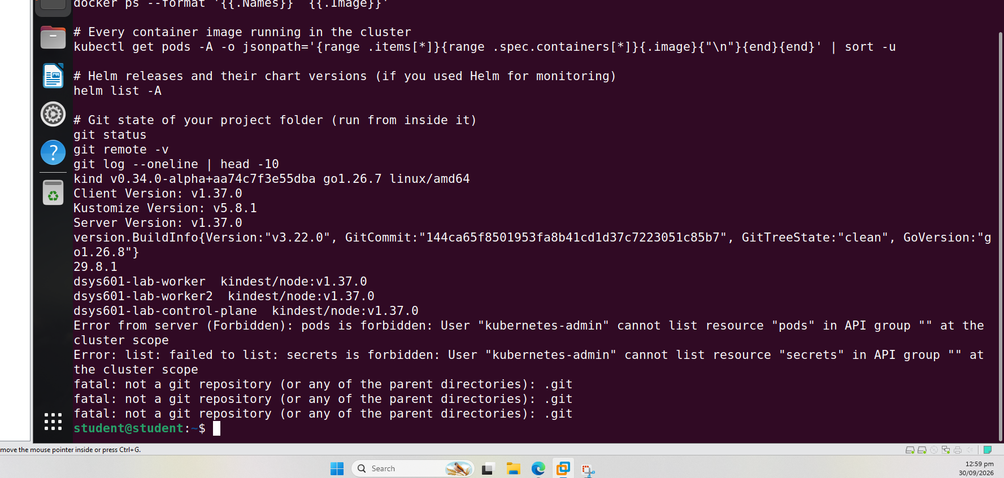
Figure 1. Version check showing the permission errors
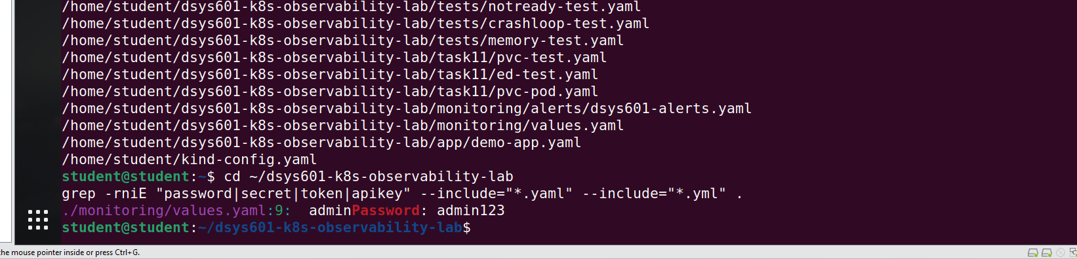
Figure 2. Secret scan found the password in values.yaml

3. What I pinned
What | Pinned to | Where
kind, kubectl, helm, docker | Exact versions | versions.env
Kind node image | Tag + sha256 digest | cluster/kind-config.yaml
Helm chart | Version 91.5.3 | versions.env
All container images | Tag + sha256 digest | app/, tests/, task11/
Grafana password | Not in git | .env (ignored by git)

I changed the leaked password so the old one no longer works. setup-cluster.sh now checks tool versions before building.
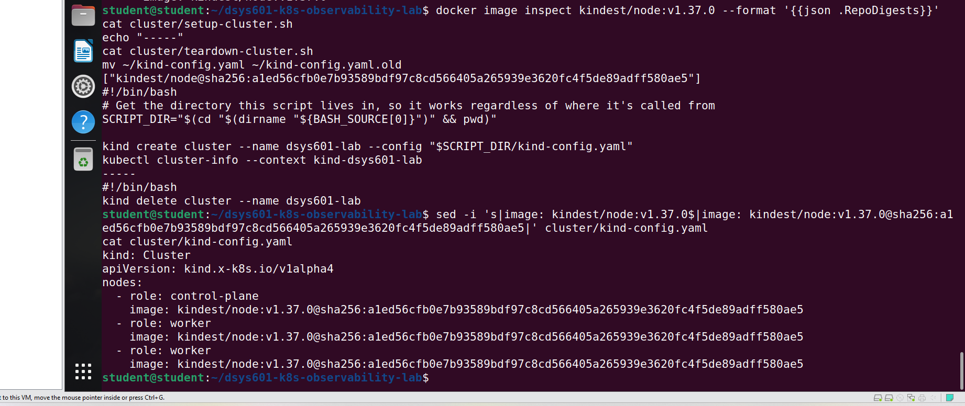
Figure 3. Node image pinned by digest
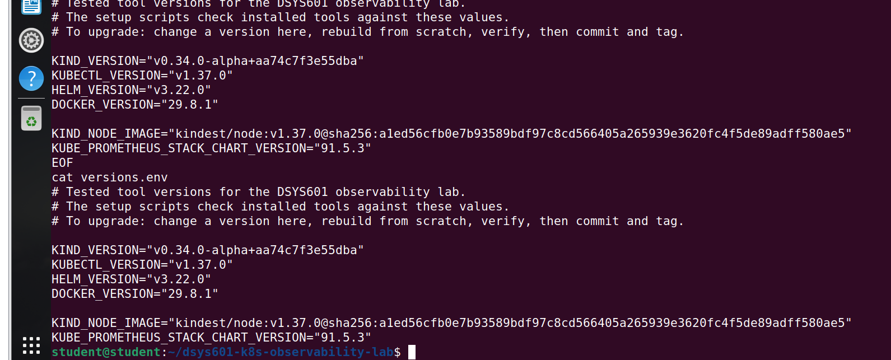
Figure 4. versions.env
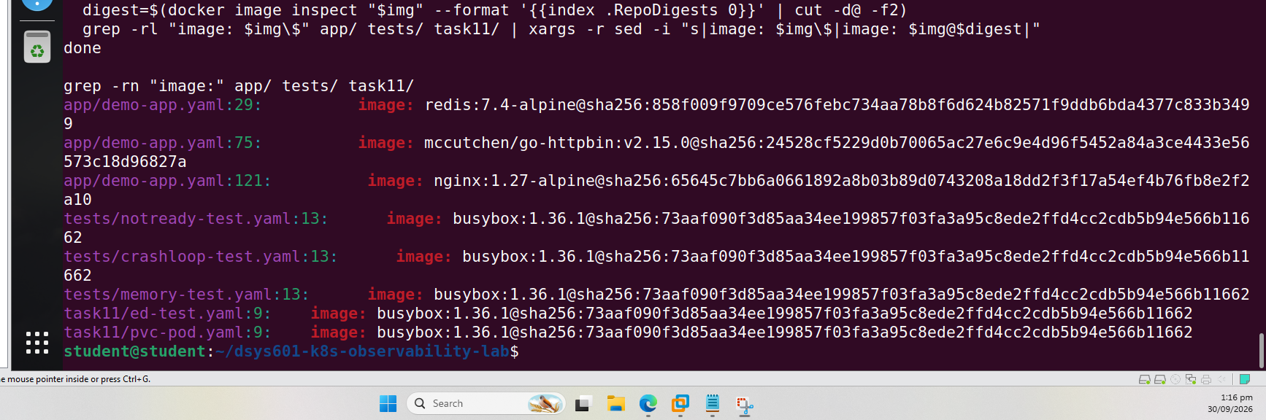
Figure 5. All container images pinned by digest

4. Rebuild test
I deleted the cluster and rebuilt everything from a fresh clone of GitHub.
git clone https://github.com/kat0870/dsys601-k8s-observability-lab.git ~/rebuild-test
cd ~/rebuild-test && cp ~/dsys601-k8s-observability-lab/.env .env
./cluster/setup-cluster.sh
kubectl apply -f app/demo-app.yaml
./monitoring/setup-monitoring.sh
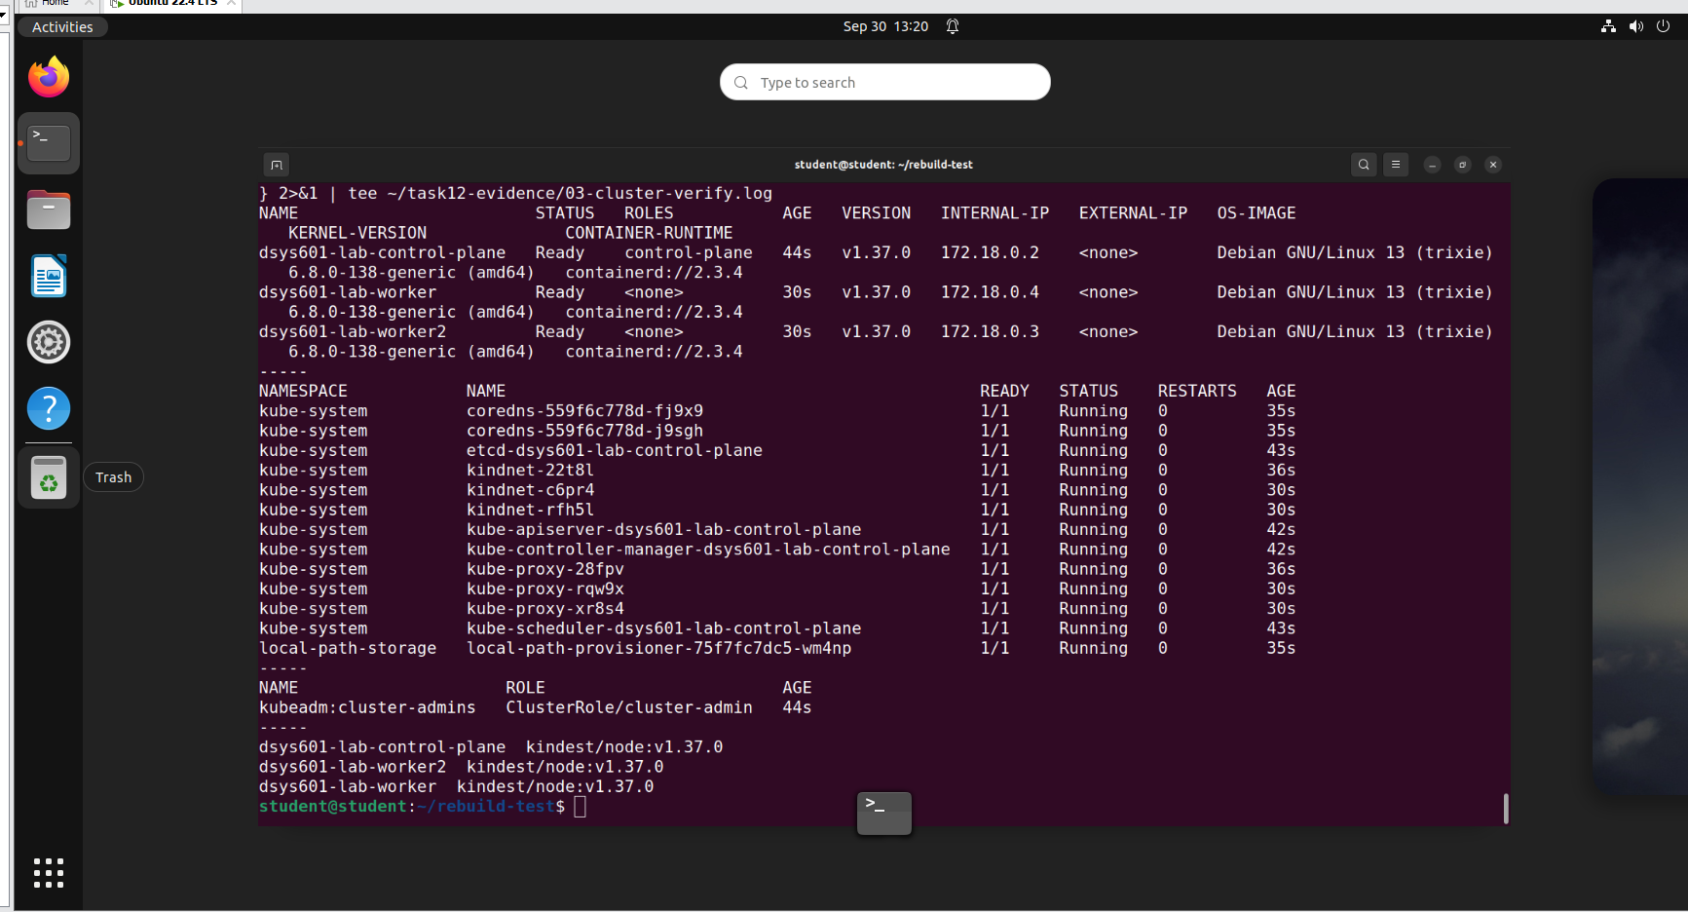
Figure 6. Rebuilt cluster: 3 nodes Ready, all system pods Running
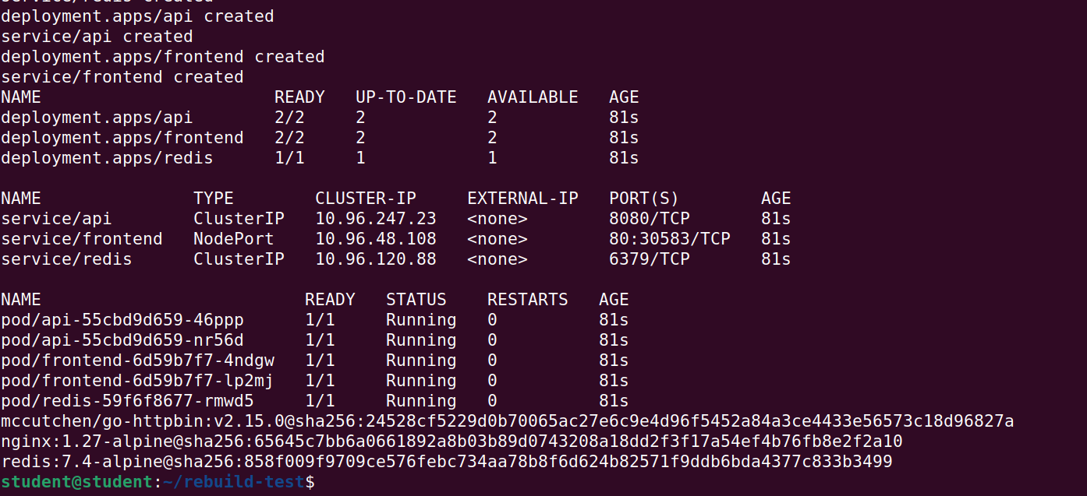
Figure 7. Demo app running from pinned images
Problem found by the test
The first monitoring install failed because values.yaml had an empty grafana: key. I changed it to grafana: {} and the second install worked.
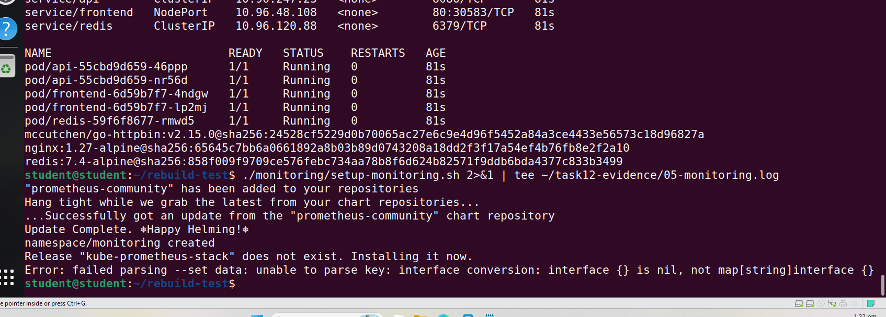
Figure 8. First install failed
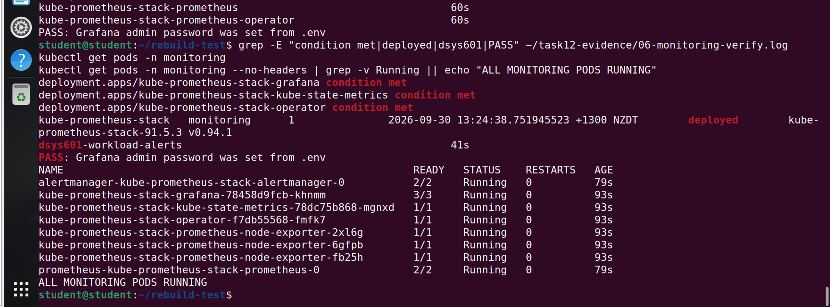
Figure 9. Second install worked: chart 91.5.3, all pods Running

5. Alert test
I ran the crashloop test on the rebuilt lab. The DSYS601PodCrashLooping alert fired after about 7 minutes, as designed.
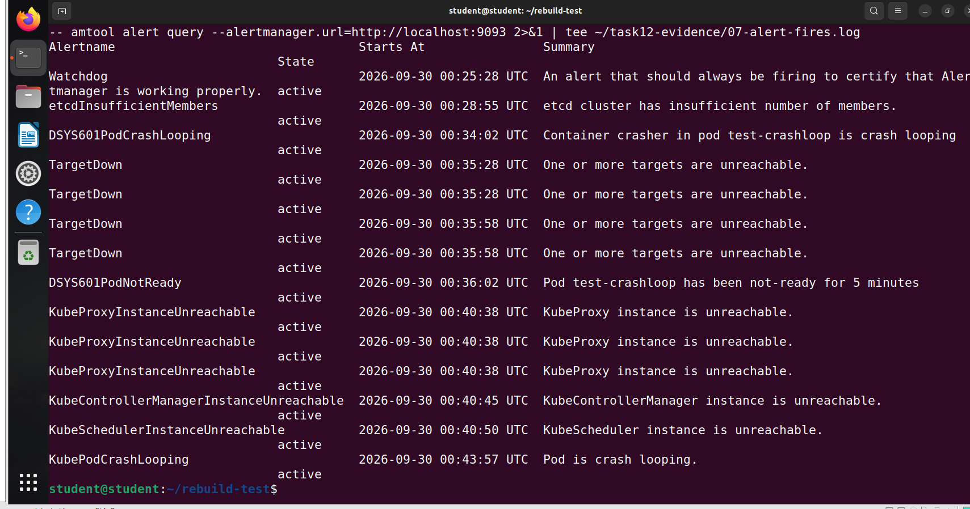
Figure 10. Alert firing in Alertmanager after the rebuild

6. Commits and tag
Commit | What it did
e6d29cc | Moved the Grafana password to .env
ea0bfbe | Pinned the node image; added versions.env and version checks
d6bb65e | Pinned all container images by digest
2d7a3ee | Fixed the empty grafana: key
76e9be9 | Added docs/reproducibility.md; tagged v1.0-lab-baseline

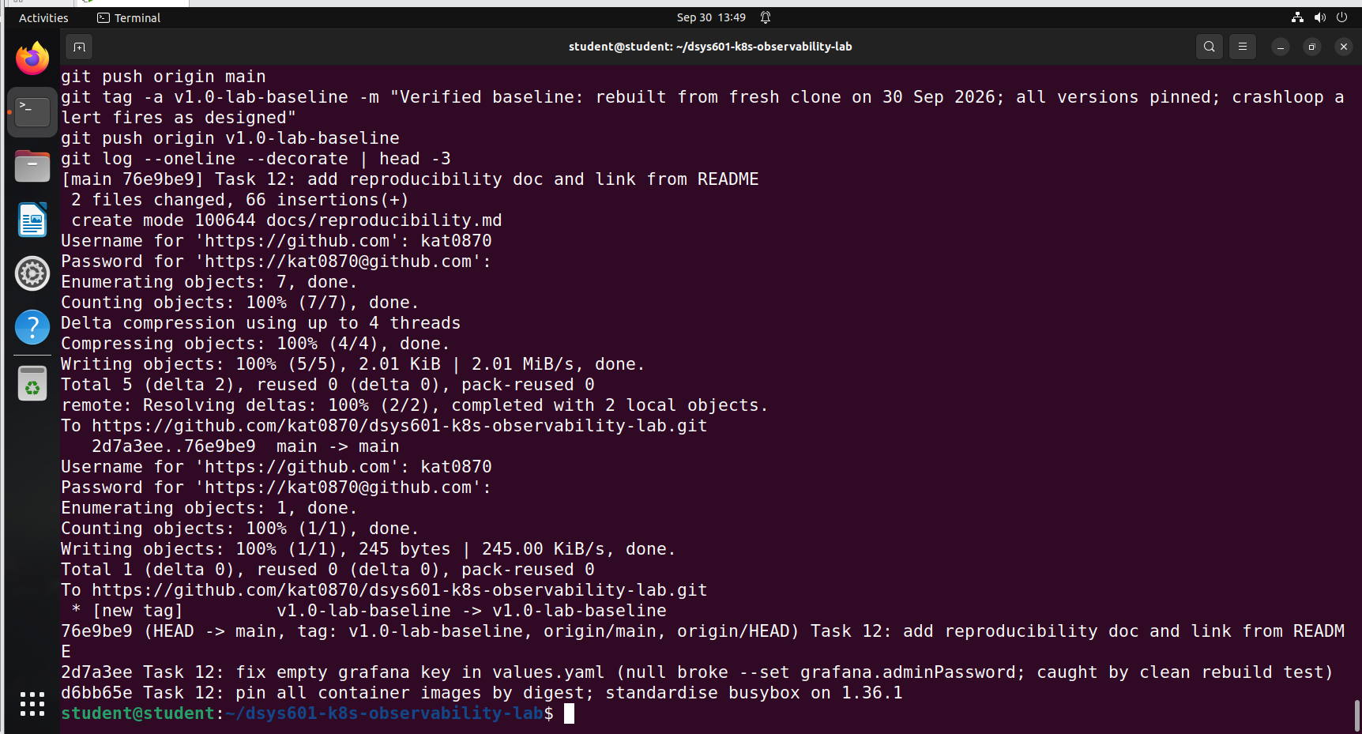
Figure 11. Final commit pushed and tagged

7. Where this leaves Task 12
Task 12 is complete. All manifests are in GitHub, every version is pinned, and a clean rebuild worked.
Open items:
Item | Next step
Kind is an alpha build | Move to a stable release (supervisor decision)
False alarms from Kind (TargetDown etc.) | Fix in the alerting setup
Tool install steps and README update | Cover in Task 14 (handover)

Next: Task 13, teardown and reset.

